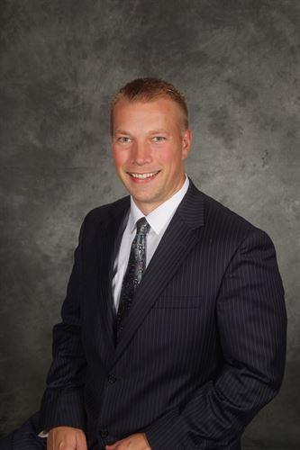
Not yet satisfied, Principal looks towards the Future

An average day is spent conducting students behavior, addressing curriculum and trying to improve the school. Not many would consider this much of a dream job.

Benjamin Mainka however, is not the average principal.
“ I love my job” he says with a smile. Principal Mainka is in the process of completing his second year at Hartland High School. As a previous middle school Principal in the Hartland school district, Principal Mainka is very passionate about his position. “I’ve always loved working with High School kids….I care passionately about my students”, he says cheerfully.

As a previous coach and a parent, Mainka is well experienced and prepared to endure any challenges he will face in his new career. “I’m not satisfied yet [with my accomplishments]” Mainka replies when asked about future challenges he predicts in his career. Since he began this new position as principal, the school has changed substantially. “There are a lot of new policies, put in place this year“ says student Maya Toll enthusiastically.

The policies have not been the only thing altered in the developing school. “[when I first took the position] there just wasn’t a lot of spirit around here” Mainka says shaking his head. Improving school spirit and culture became a major goal for Principal Mainka, which has been the driving force behind for many new programs implemented in the two thousand twelve school year. Pre-game, a new program Mainka has implemented, has been a major success. " it provides a fun and safe environment encouraging school spirit" he explains. “pre-game is lots of fun” says student Kassady Halstead. The success of already implemented programs, has encouraged Mainka to persist to achieve his goals. “ This new year we will also be trying some new programs” he states optimistically. His enthusiasm for his job will benefit all of Hartland High School. " I'm very proud of the work I've done" he says with a smile, " but I'm not satisfied yet".

